Chandani
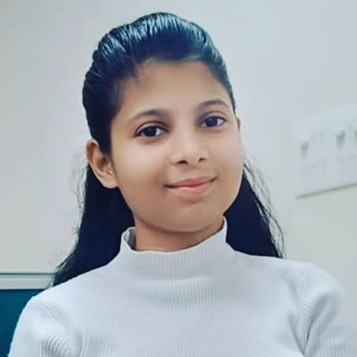
E-2/112 Meer vihar, delhi-110081
contact : 9650581493
E-mail : chandaniverma418@gmail.com

Objective

- Seeking an entry level position to begin my career in a high level professional environment.

Experience

- Fesher

Education

S. No. | Qualification | Institution | Duration (y) | Marks in  (%) | Joining date | Completing date
1 | ADIT | Nsti(noida) | 2 year | _ | September 2022 | pursuing
2 | ITI | Iti pusa | 1 year | 85.00% | August  2020 | August  2021
3 | 12th | RPVV Rohini | 1year | 80.00%
4 | 10th | Sarvodya co-ed school | 1 year | 81.00%

Technical skills

- Web Development ( HTML, CSS, JAVASCRIPT )
- English Typing(35wpm)
- Hardware and Software installation
- Open Office
- Computer Management
- Microsoft Office
- Computer Networking

Soft skills

- Communication Skills
- Quick Learning
- Problem solving
- Listening
- Time Management

Language known

Profficiency In
- English
- Hindi

Personal Details

- Nationality : Indian
- Date of Birth : 02/07/2002
- Marrital Status : Unmmarried

Declaration

- I hereby declare that all the information furnished above is true to the best of my belief.
Chandani

